Task 1: Create AWS custom network (VPC and subnets)

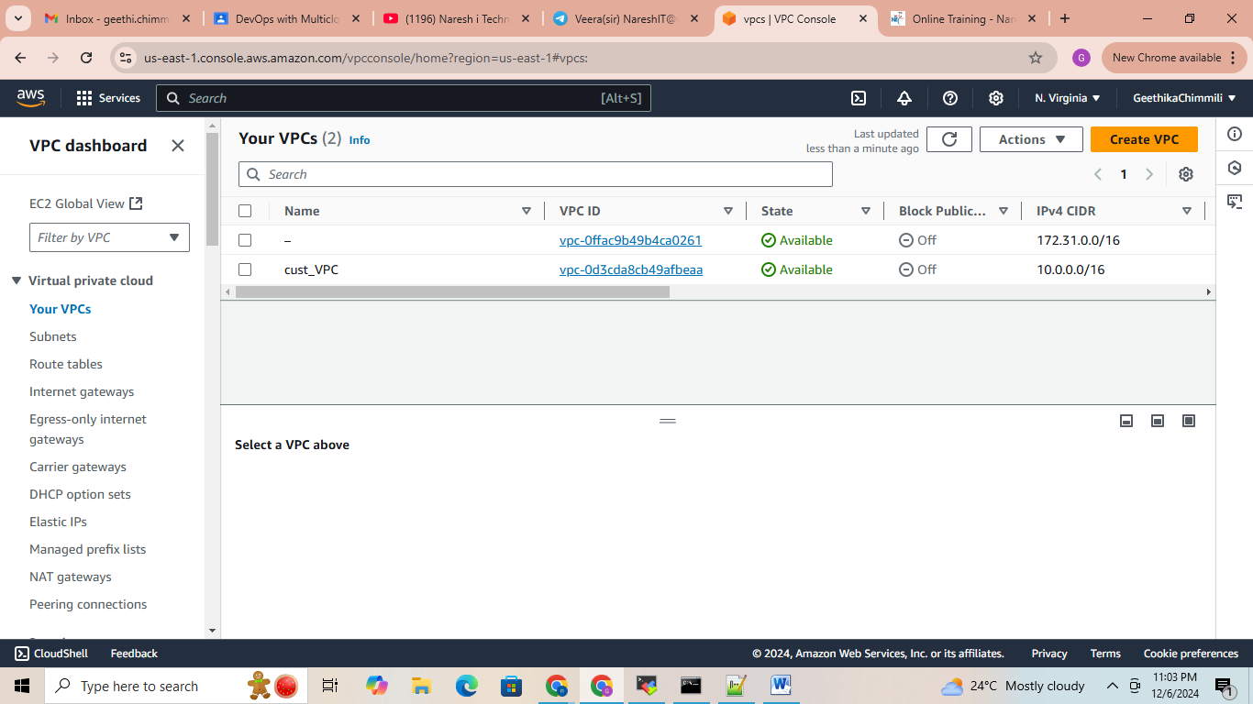

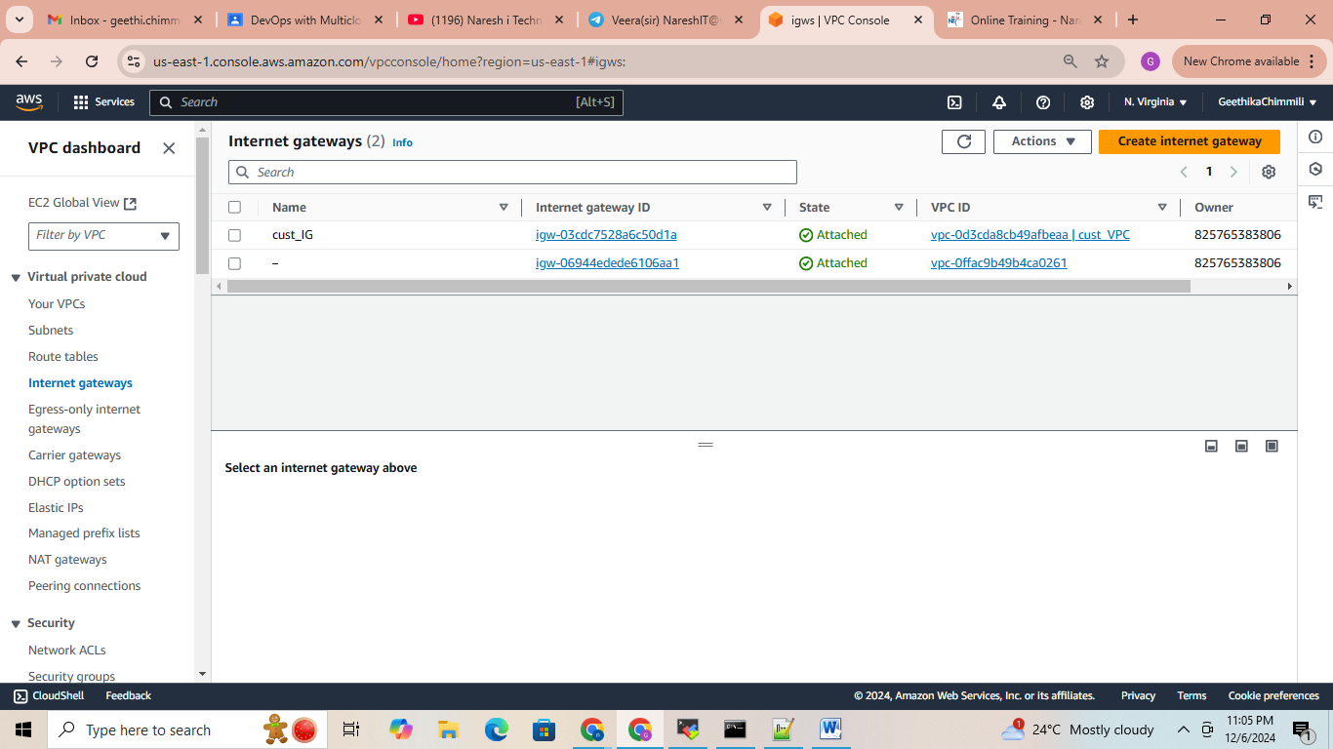

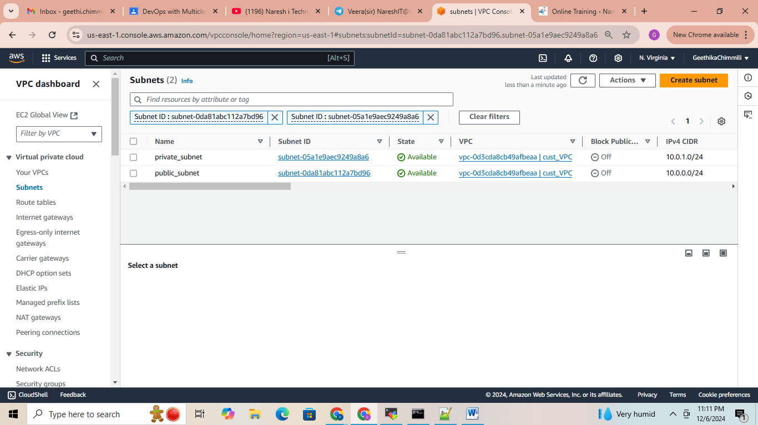

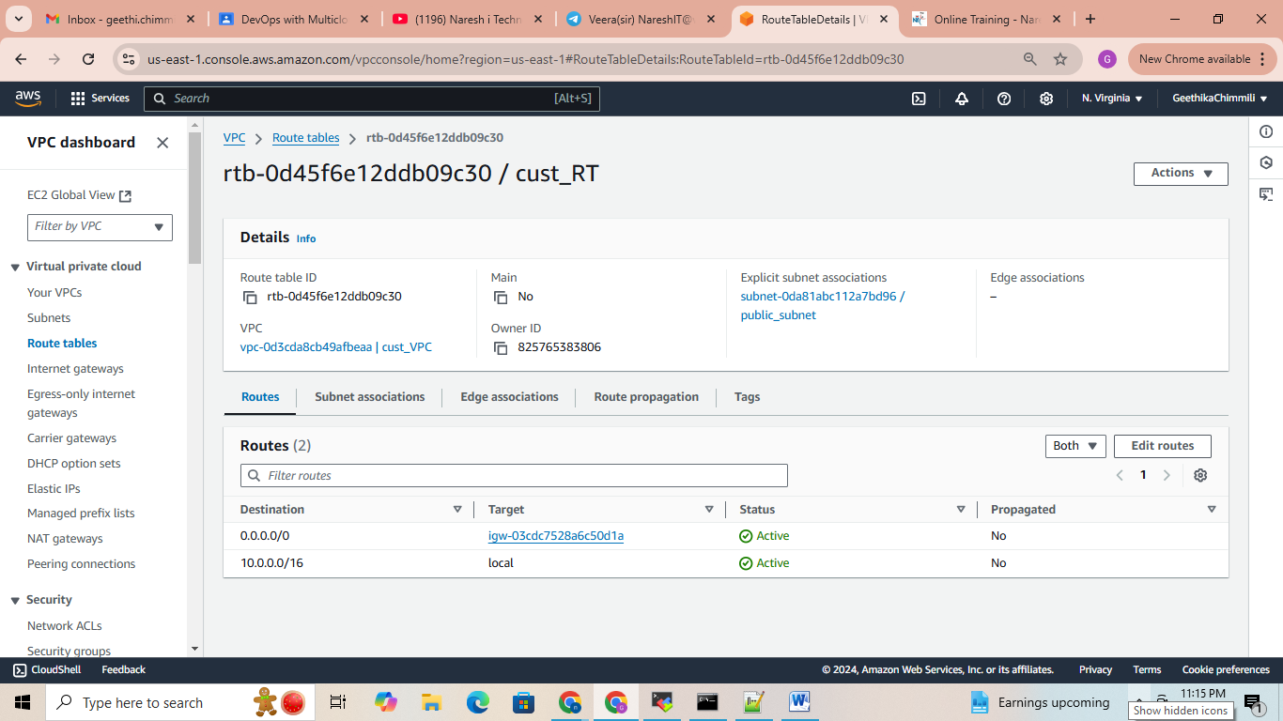

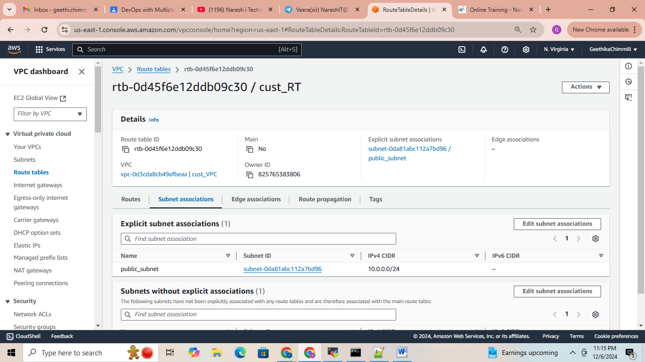

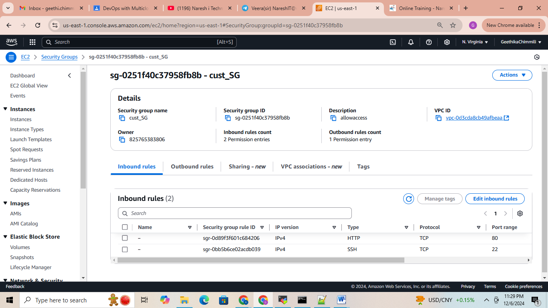

Task 2: Launch public EC2 instance

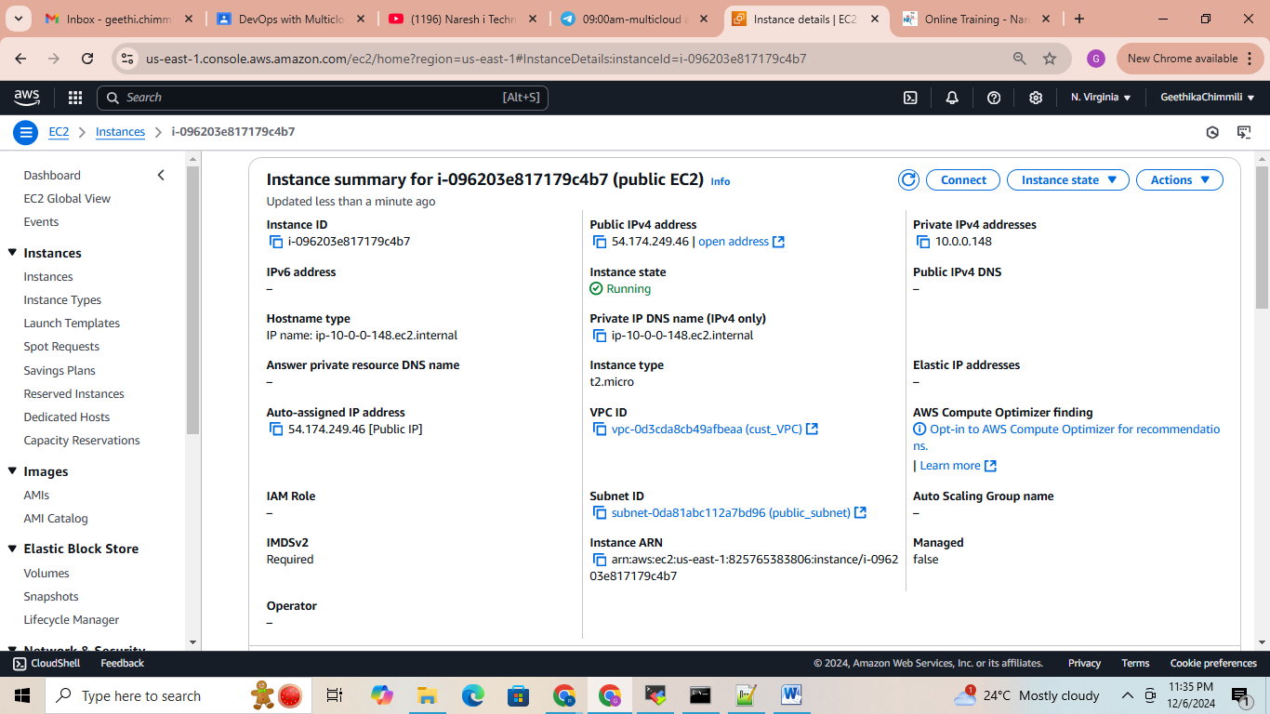

Task 3: Launch private EC2 instance

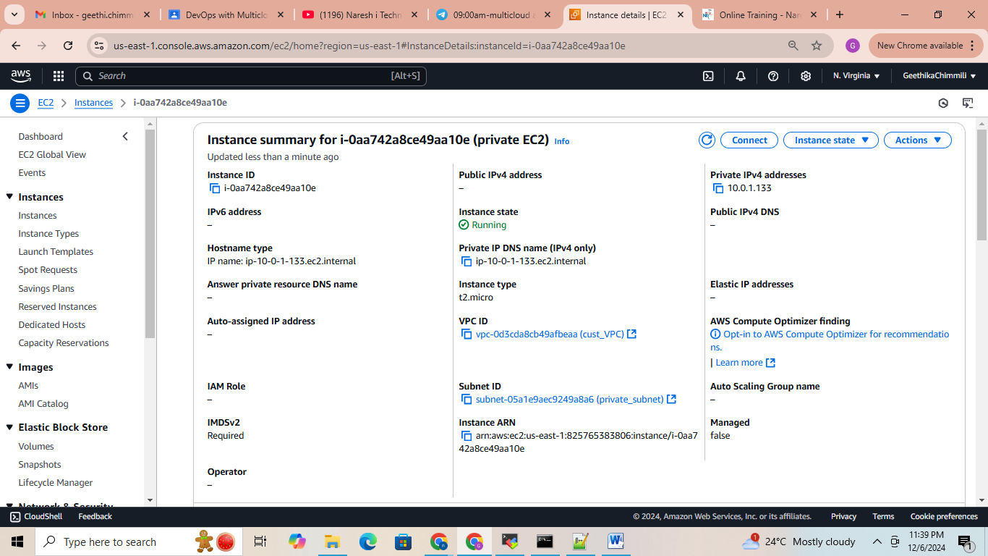

Task 4: Connect public EC2 instance from your laptop

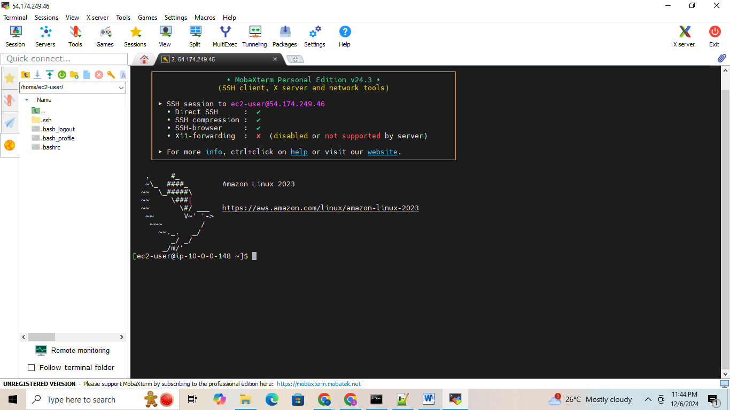

Task 5: Disable SG rule and access again Note down the error

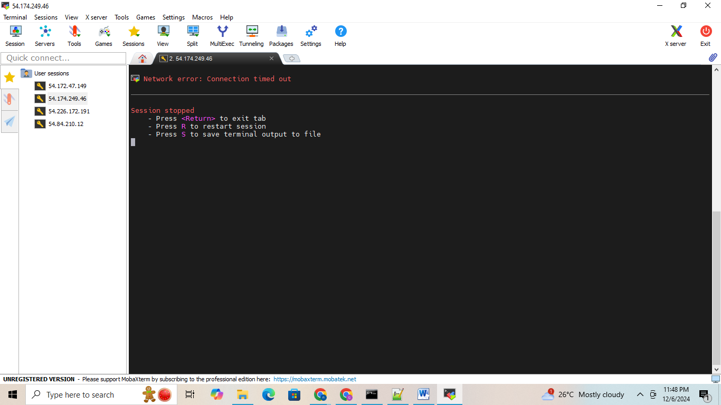

Task 6: Try to connect with wrong pem file and note down the error

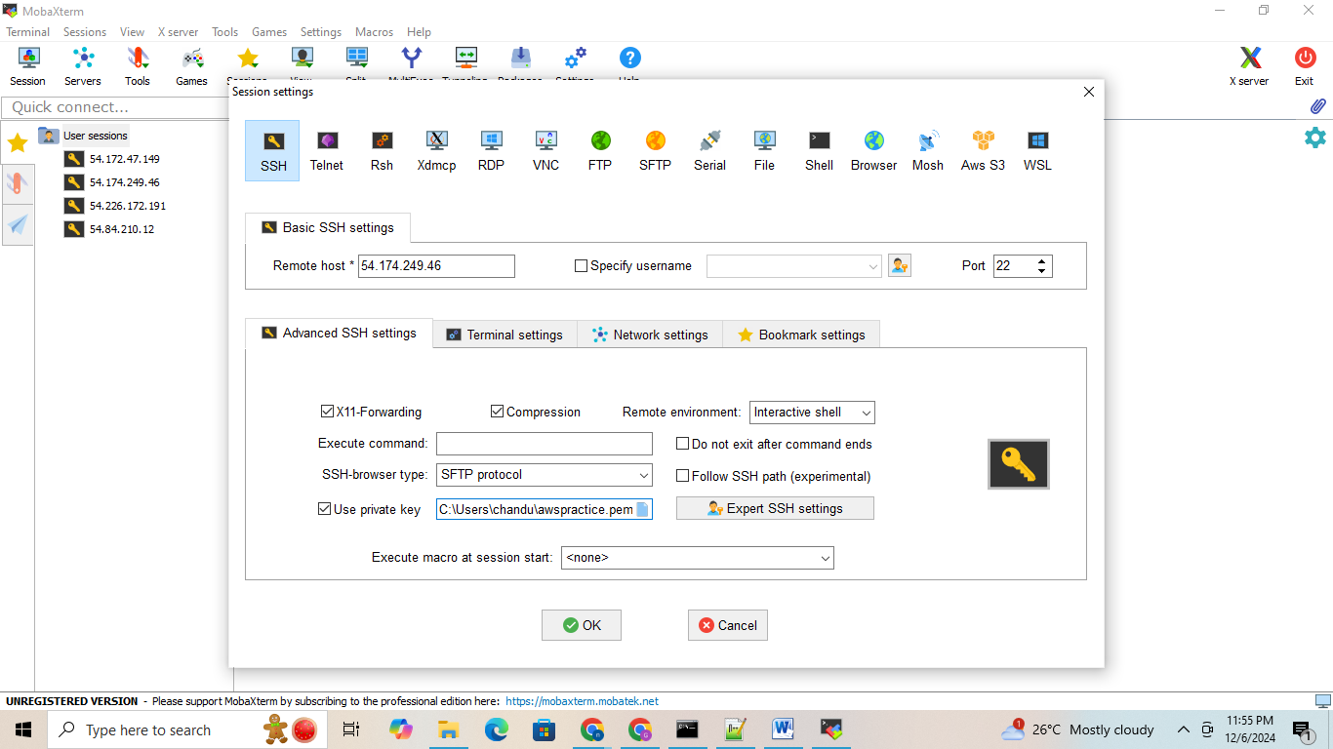

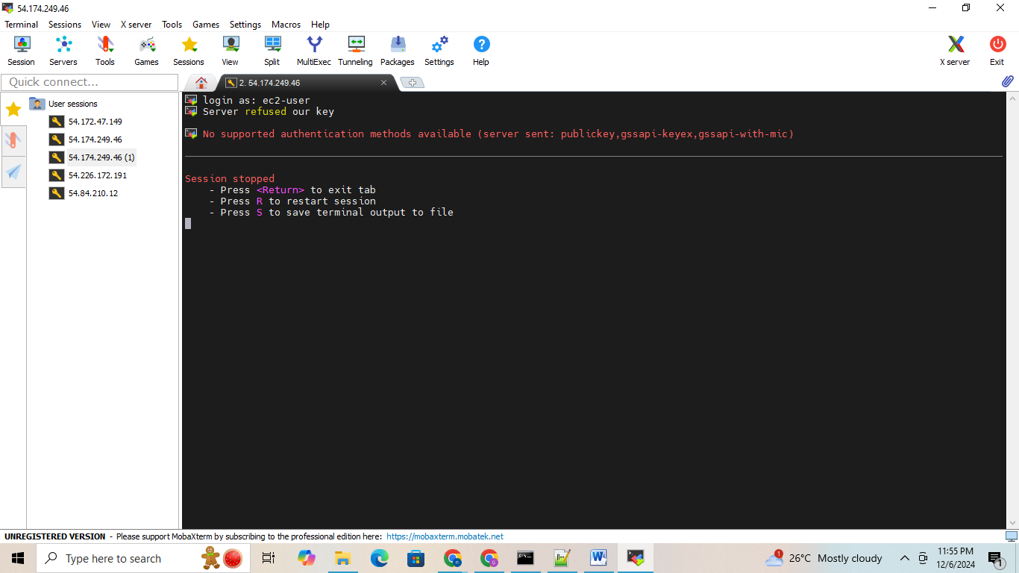

Task 7: Try to connect your private EC2 by using Bastion Host Process

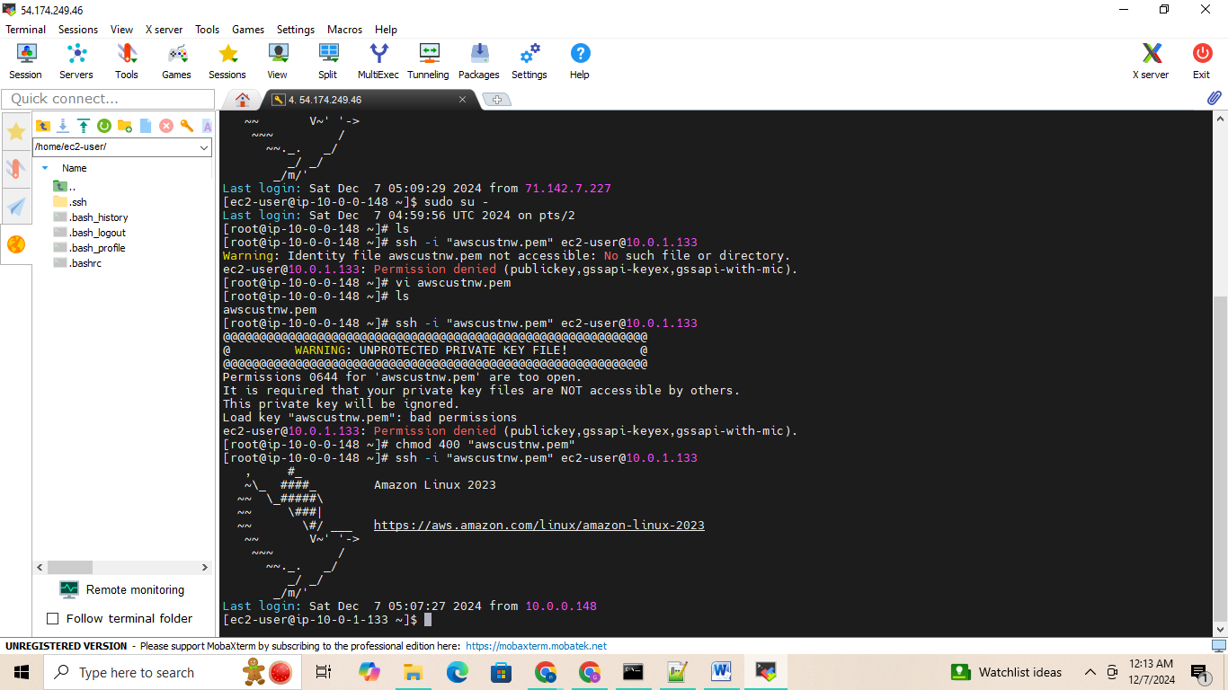

Task 8: Create NAT Gateway and give internet access to private EC2

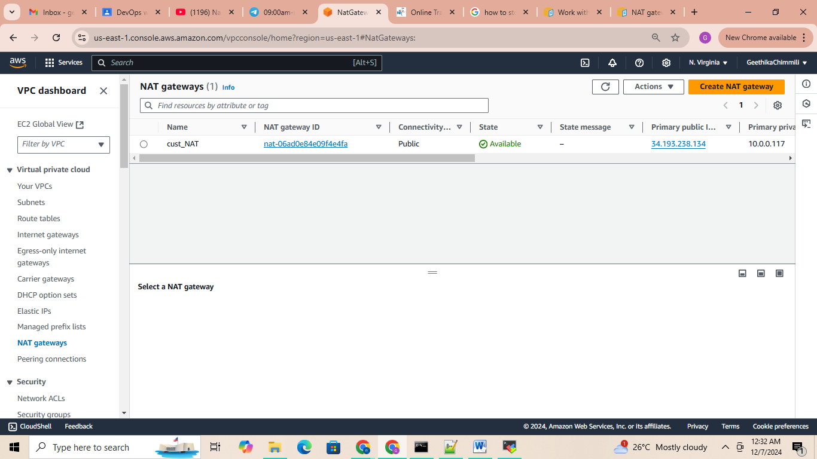

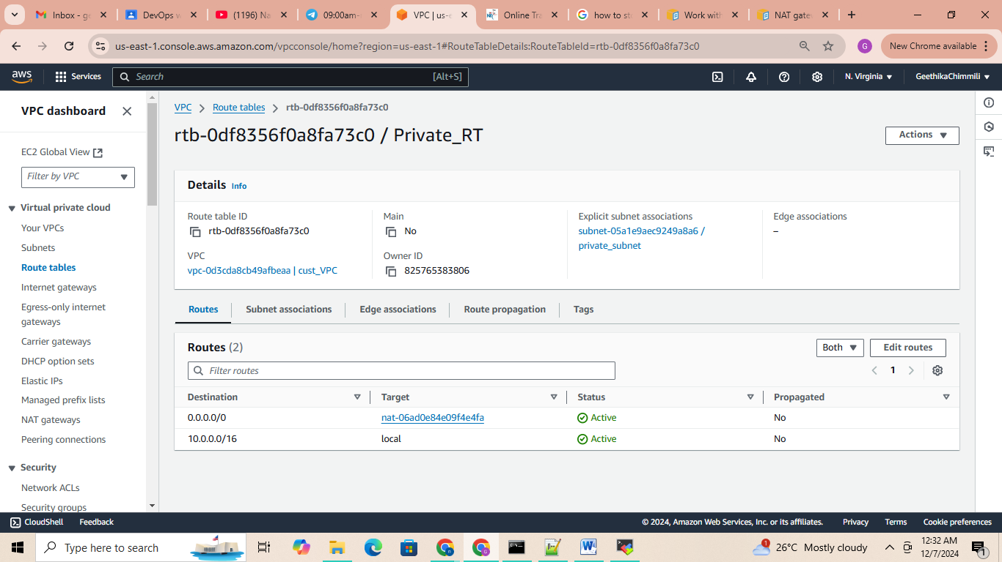

Task 9: Try to access internet from Private EC2 ---command: ping google.com

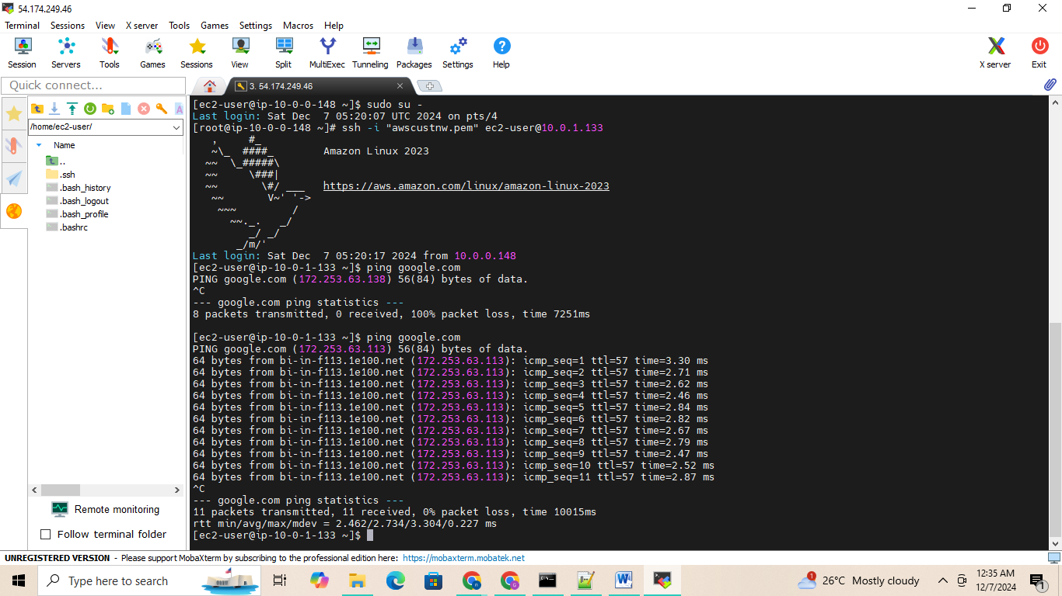

10. Disable the NAT routing path and try to connect again and note down the error

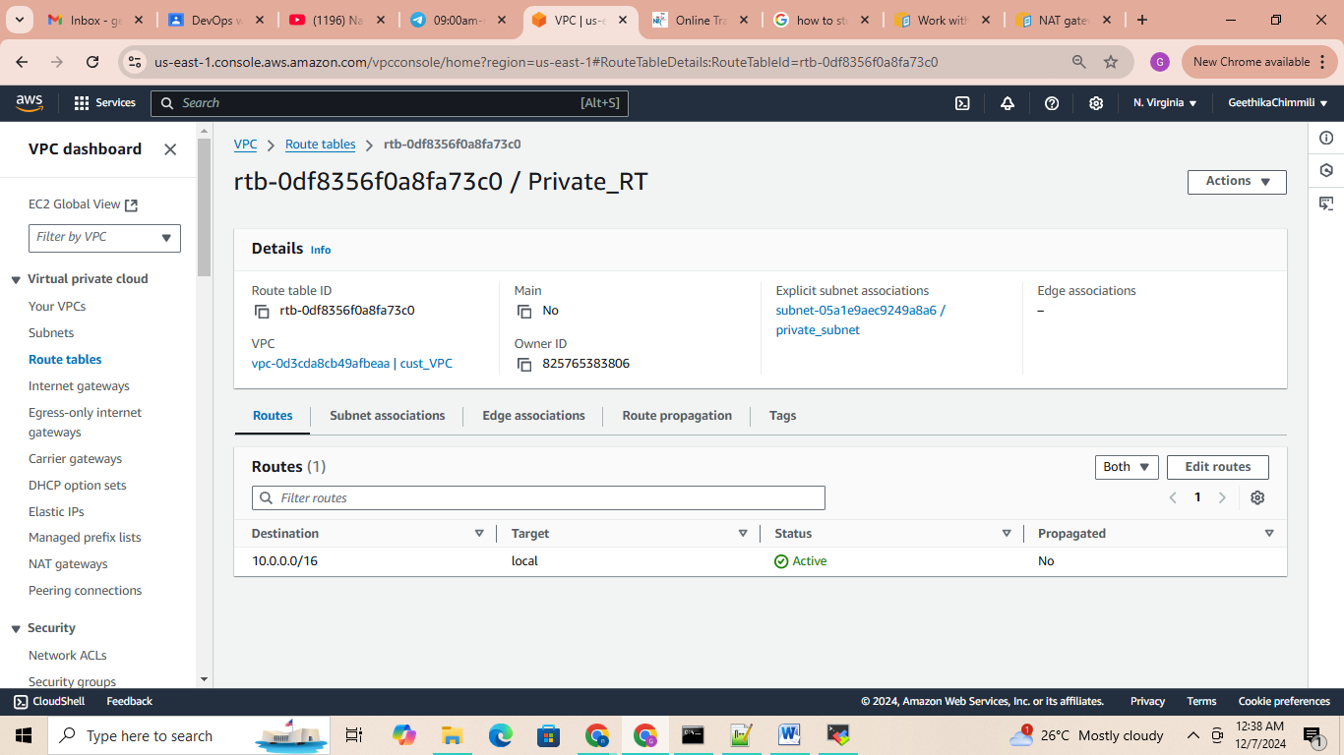

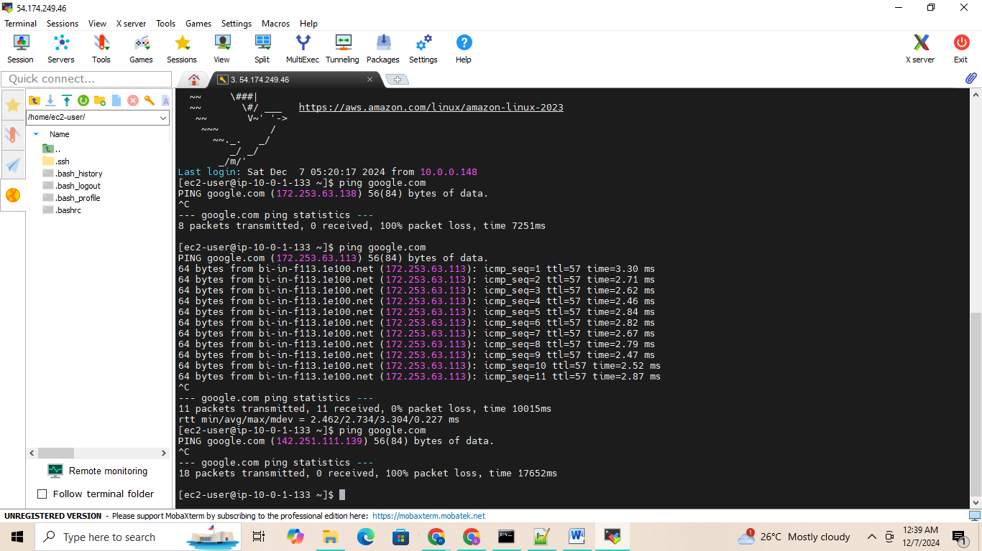

After enabling again:

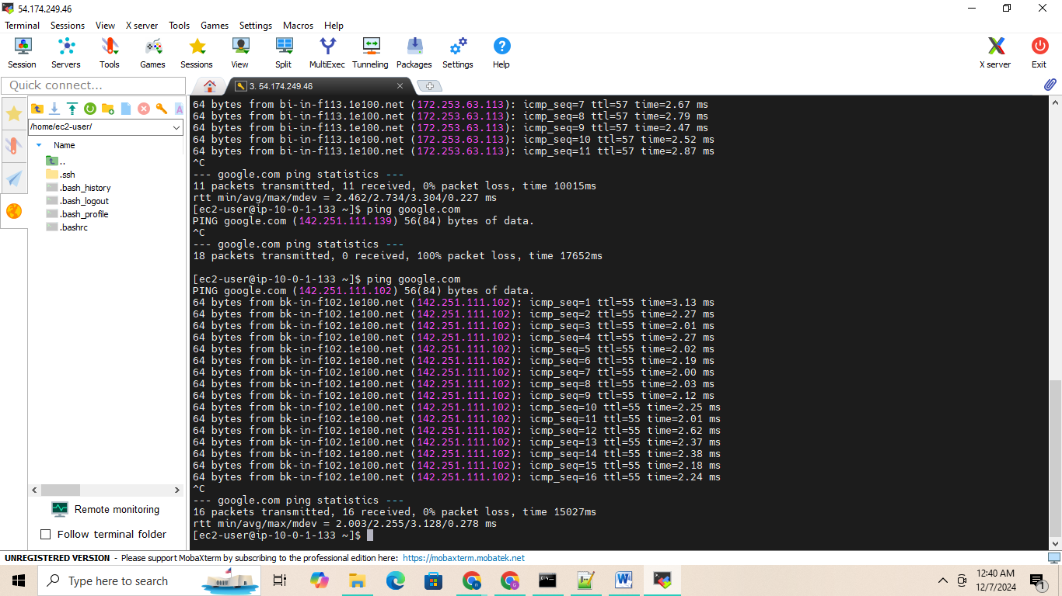

Task 11: Do the practice on CIDR create VPC with diff CIDR range ex: 10.0.0.0/24

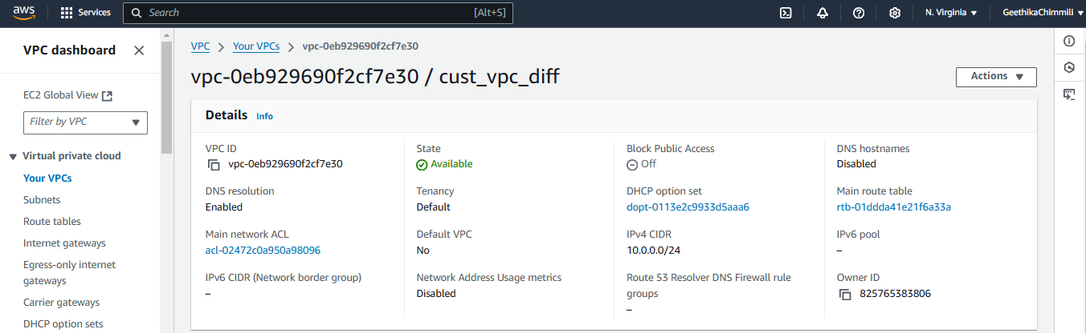

Task 13: Create VPC with 10.0.0.0/24 range and create subnets in this range.

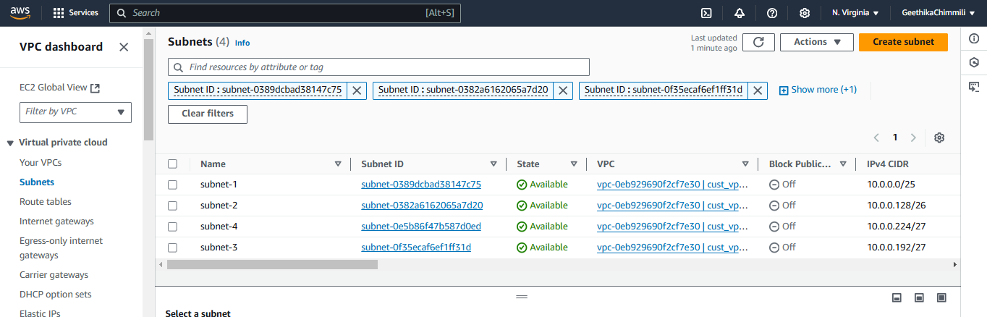

Task 14: 14. Clear all created resources

